**Object oriented Project**

**Monitored and Supervised By**

**ENG. Lamia**

**Developed By**

**Gerges Tharwat 41810090**

**Tadros Eshak 41810275**

**Maria Samy 41810123**

**Yasmine Ayman 41810051**

**Mark Fady 41810042**

**Table of Contents**

1.Introduction 3

2.Motivation 3

3.Use Case Diagram 4

3.1.Use Case Diagram for Receptionist and Patient 4

3.2.Another diagram for Receptionist and user 5

3.3.Medical History use case 6

4.Class Diagram 6

5.Object Diagram 4

6.Activity Diagram 5

6.1.Receptionist , doctor with server 4

6.2.Sign In 5

6.3.Receptionist , doctor with patient 6

7.Sequence Diagram 6

7.1.Patient Diagnoses 4

7.2.Sign up 5

7.3.Request Reservation 6

8.Estate Chat 3

8.1.Patient registration 4

8.2.Receptionist registration 5

8.3.Doctor Reservation 6

9.Components Diagram 4

9.1.Files of Patient , Receptionist&Doctor 4

9.2.Patients types &purpose of Receptionist,Doctor 5

10.Deployment Diagram 5

11.Collaboration Diagram 5

**1)Introduction**

----------------

We’re talking about Hospital system where,we used “UML” diagrams to provide information about how our system works and state the communication between different Actors ,Also to show the purpose of our features and show how it works under different situations.

**2)Motivation**

Doctors and employees suffer from large numbers of patients that make the feel so frustrated, confused and tired. Patients suffer from waiting every day for the doctor to check them and help them to have a better health these reasons help us to make hospital management system which helps both the patient and doctor. It helps the patient to request a time and room for a specific specialization and send his/her data .

It helps doctors and receptionists to deal with patients in an organized way than before . It helps both of them to save the patient data without missing .

**3)Use Case Diagram**

This Use Case Diagram is a graphic depiction of the interactions among the elements of our integrated system.it represents the methodology used in system analysis to identify, clarify and organize system requirements of our system. In other words, a use case describes “who” can do “what” with the system in question. The use case technique is used to capture a system’s behavioral requirements by detailing scenario-driven threads.

**3.1Use Case Diagram for Receptionist and Patient**  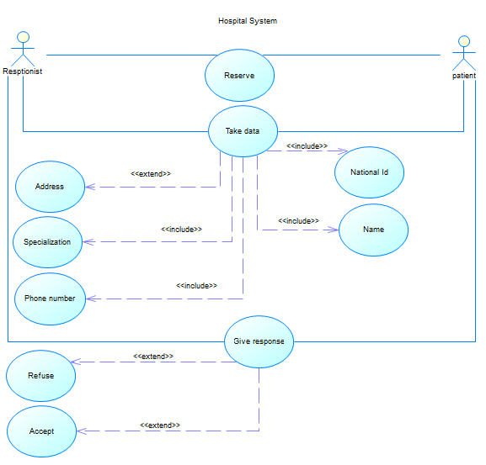

**3.2 Another diagram for Receptionist and user**

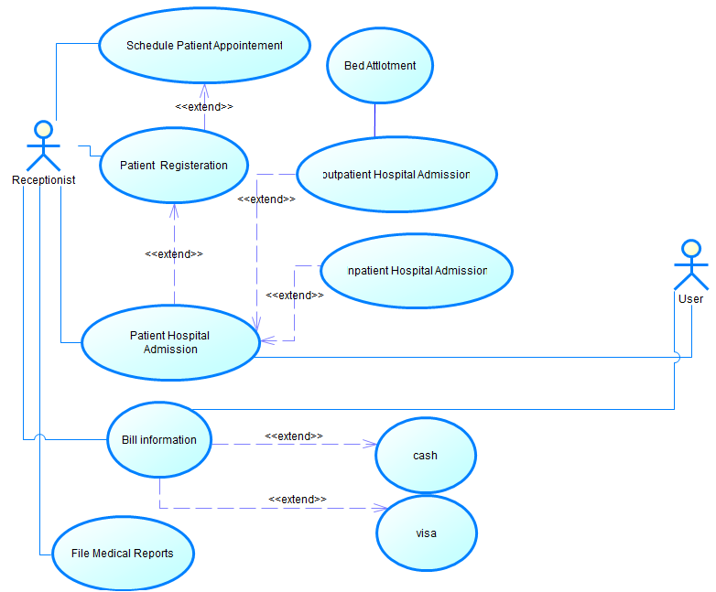

**3.3 Medical History use case**

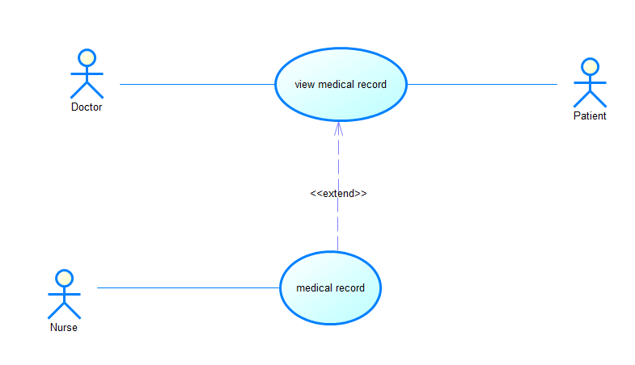

1. **Class Diagram**

is a static structure diagram which describes system structure by using classes ,attributes and functions

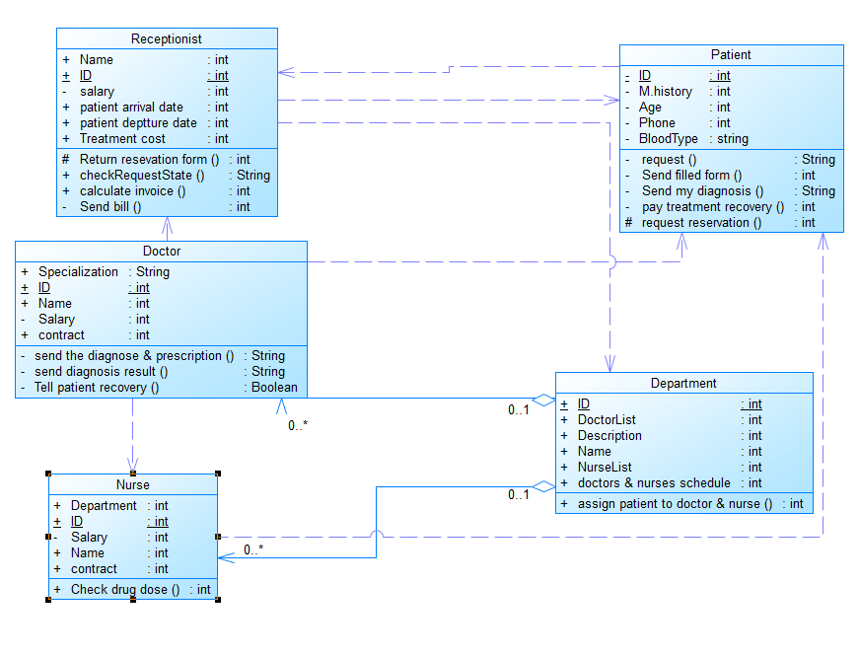

1. **Object Diagram**

An object diagram is a graph of instances, including objects and data values. A static object diagram is an instance of a class diagram; it shows a snapshot of the detailed state of a system at a point in time. The use of object diagrams is fairly limited, namely to show examples of data structure."

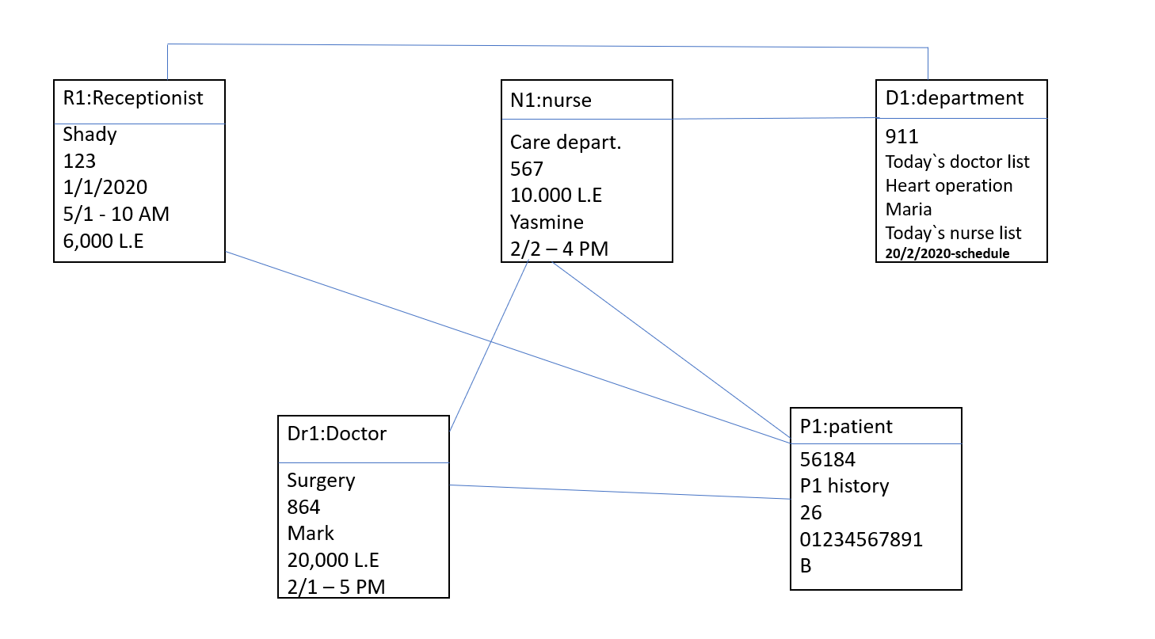

1. **Activity Diagram**

An activity diagram is used by developers to understand the flow of programs on a high level. It also enables them to figure out constraints and conditions that cause particular events. A flow chart converges into being an activity diagram if complex decisions are being made

**6.1 Receptionist , doctor with server**

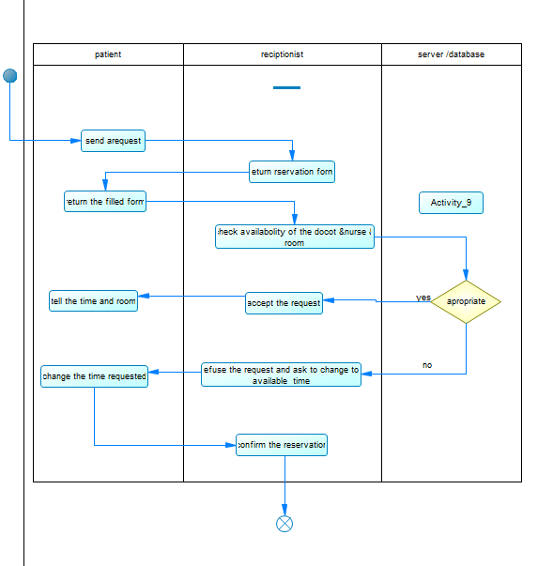

**6.2 Sign in**

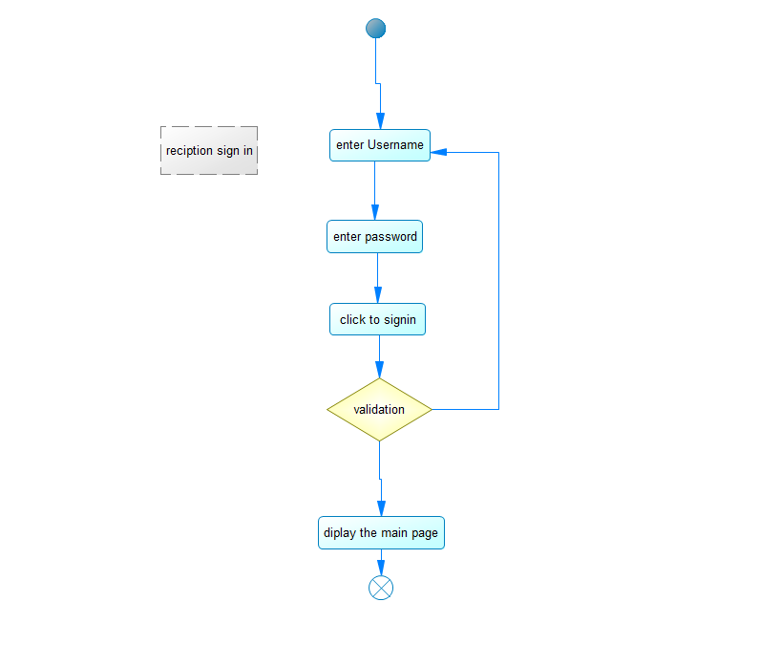

**6.3 Receptionist , doctor with patient**

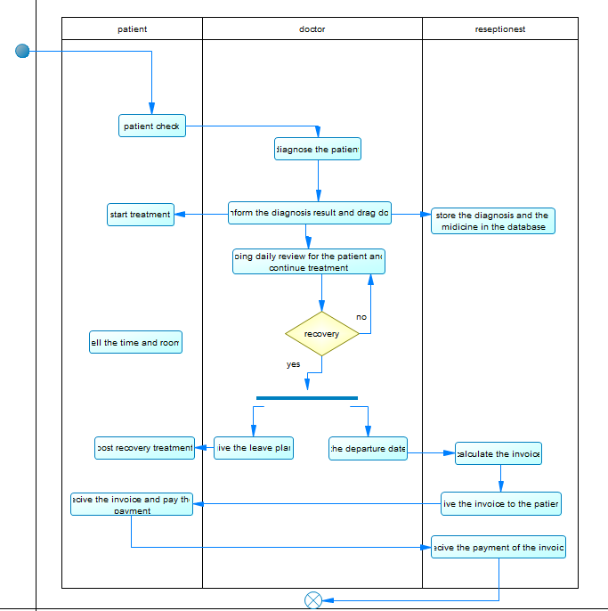

1. **Sequence Diagram**

A sequence diagram is a type of interaction diagram because it describes how—and in what order—a group of objects works together. These diagrams are used by software developers and business professionals to understand requirements for a new system or to document an existing process

**7.1)Patient Diagnoses**

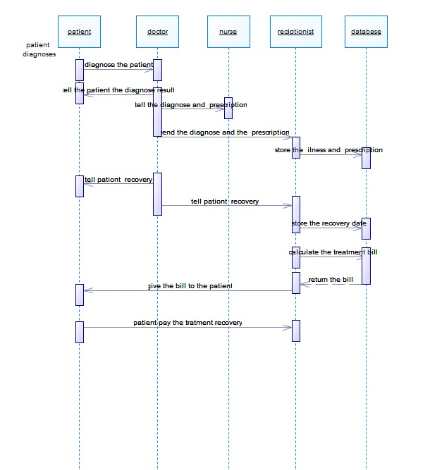

**7.2)Sign Up**

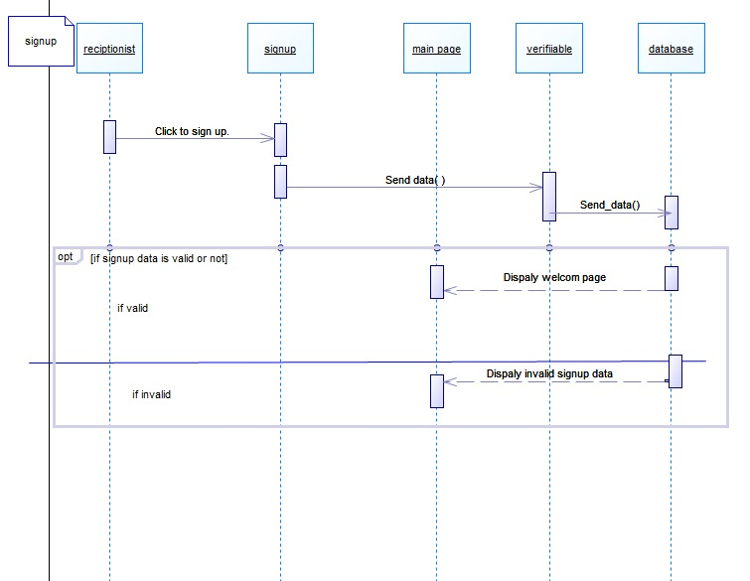

**7.3)Request Reservation**

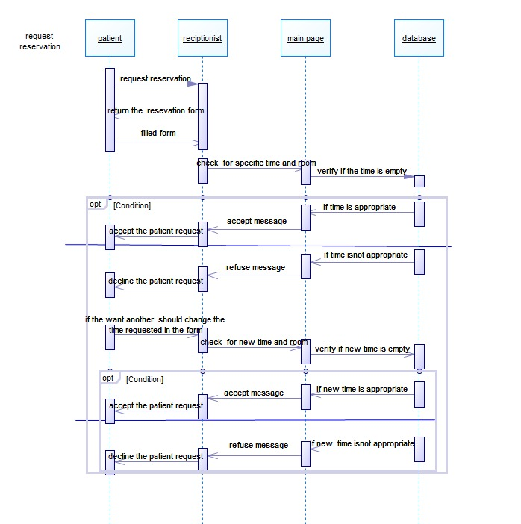

1. **Estate Diagram**

the most important purpose of Statechart diagram is to model lifetime of an object from creation to termination. Statechart diagrams are also used for forward and reverse engineering of a system. However, the main purpose is to model the reactive system. To

**8.1)Patient Registration**

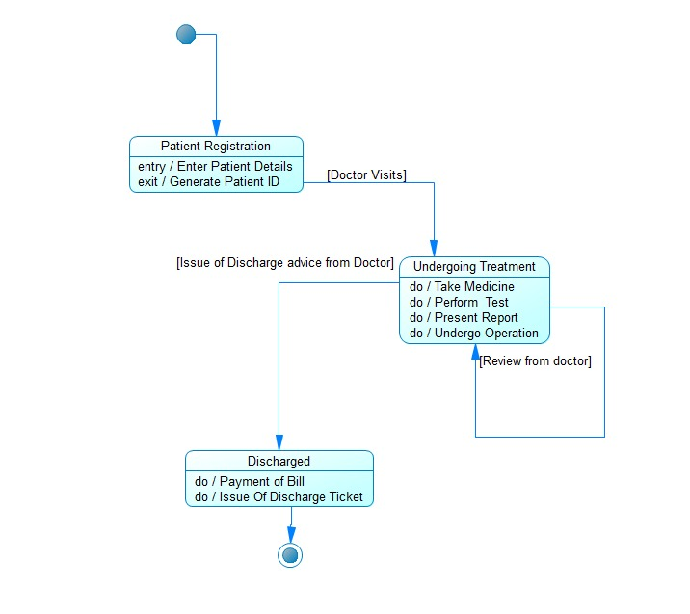

**8.2)Receptionist Registration**

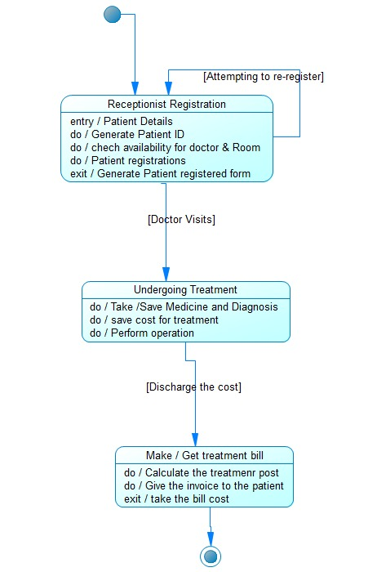

**8.3)Doctor Registration**

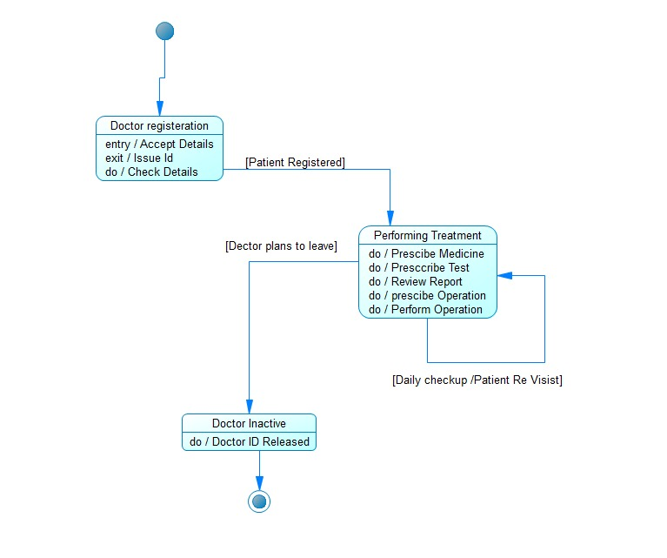

1. **Component Diagram**

This UML component diagram shows how a software system will be composed of a set of deployable components—dynamic-link library (DLL) files, executable files, or web services—that interact through well-defined interfaces and which have their internal details hidden.

**9.1)Files of Patient , Receptionist&Doctor**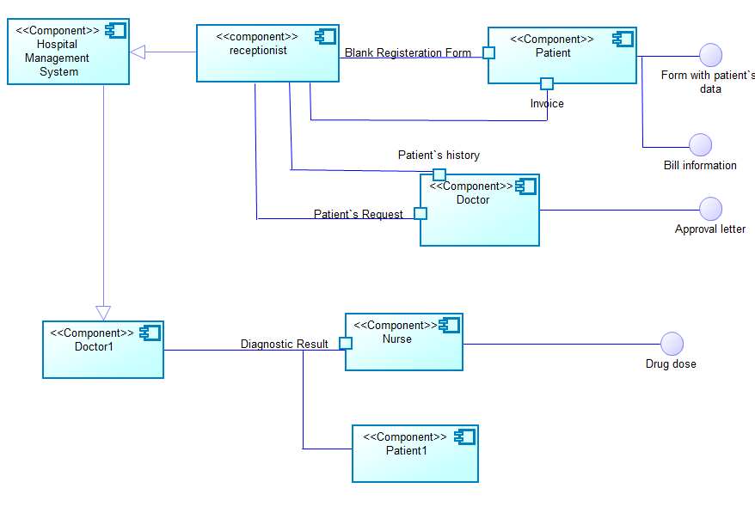

**9.2)Patients types &purpose of Receptionist,Doctor**

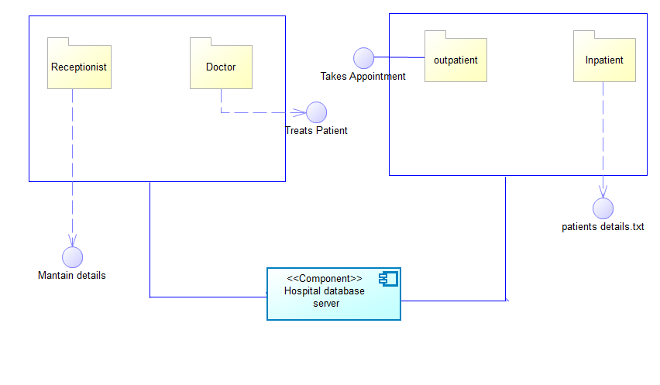

1. **Deployment Diagram**

present a static view of the implementation. It includes physical resources which is nodes . Each node represents a processing resource and each node is responsible for one or more software components.

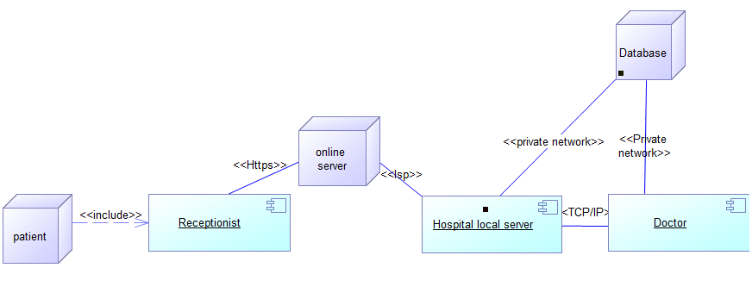

1. **Collaboration Diagram**

A collaboration diagram is a type of visual presentation that shows how various software objects interact with each other within an overall IT architecture and how users can benefit from this collaboration. A collaboration diagram often comes in the form of a visual chart that resembles a flow chart. It can show, at a glance, how a single piece of software complements other parts of a greater system.

